**Lab Exercise 2- Working with Loop (read an Excel file row by row)**

Here’s a **lab exercise** to learn how to loop through each row in an Excel sheet using **Power Automate Desktop (PAD)**. This exercise assumes you have PAD installed and an Excel file to work with.

**Objective**

Build a flow in Power Automate Desktop to read an Excel file row by row, extract values from specific columns, and log the information.

**Scenario**

You have an Excel file named EmployeeData.xlsx with the following columns:

* **EmployeeID**
* **Name**
* **Department**
* **Salary**

You need to read each row, process the data, and log each employee's details.

**Steps to Create the Flow**

**Step 1: Prepare the Excel File**

1. Create an Excel file EmployeeData.xlsx with the following content:

| **EmployeeID** | **Name** | **Department** | **Salary** |
| --- | --- | --- | --- |
| 101 | Alice | HR | 55000 |
| 102 | Bob | IT | 75000 |
| 103 | Charlie | Finance | 60000 |

1. Save the file in a known directory (PowerAutomate).

**Step 2: Design the Flow in PAD**

1. **Launch Power Automate Desktop**:
   * Open PowerAutomate and create a new flow named **"Loop Through Excel Rows"**.
2. **Add Actions**: Follow these steps to build the flow:
3. **Launch Excel**

* Drag and drop the **"Launch Excel"** action.
* Set the following:
  + **Launch Excel with the following document**: Enable and provide the path to EmployeeData.xlsx.
  + **Make instance visible**: Enable (optional for debugging).
  + **Open as Read Only**: Disable.

**2. Get Rows from Excel Worksheet**

* Drag and drop the **"Read from Excel Worksheet"** action.
* Set the following:
  + **Retrieve**: All available values from the worksheet.
  + **Store values in**: ExcelData (or any variable name).
* This action reads all rows into a variable.

**3. Loop Through Rows**

* Drag and drop the **"For Each"** action.
* Set the following:
  + **Value to iterate**: ExcelData.
  + **Current item**: CurrentItem (variable that holds the row being processed).

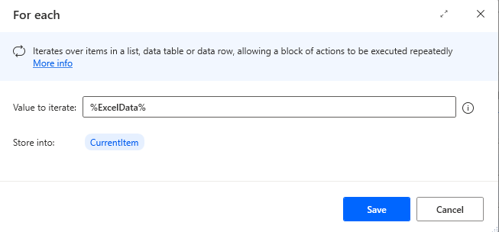

**4. Log Employee Details**

* Inside the loop, add a **"Display Message"** action to log the row details.
* Set the following:
  + **Message to Display**:

EmployeeID: % CurrentItem[0]%

Name: % CurrentItem[1]%

Department: % CurrentItem[2]%

Salary: % CurrentItem[3]%

*(Adjust the indices [0], [1], etc., based on the column positions.)*

**5. Close Excel**

* After the loop, drag the **"Close Excel"** action.
* Set **Save Document** to **Don't Save** (or Save, based on your needs).

**Final Workflow**

**Expected Output**

* For each row in the Excel file, a message box displays the employee details:
  + **Example**:

EmployeeID: 101

Name: Alice

Department: HR

Salary: 55000